SERVING PERSONAL PROTECTION ORDER PAPERWORK
 | Time Requirement | Personal Service? | Certified/Registered Mail? | First Class Mail?
Personal Protection Order | None | Yes | Yes | No
Amended/Extended PPO | None | If original PPO served, then delivery to Respondent or member of their usual residence who is of suitable age & discretion.  If original NOT served, then serve according to above row for “Personal Protection Order.” | If original PPO served, then ok to serve this way.  If original NOT served, then serve according to above row for “Personal Protection Order.” | YES, to the address listed on Respondent’s response
Respondent’s Motion to Modify or Terminate/Petitioner’s Motion to Modify | At least 7 days before hearing | No | Yes | No
Motion to Enter | 1 day before hearing for domestic & stalking PPOs; 2 days before hearing for SA PPO | Yes | Yes | No
Petitioner’s Motion to Show Cause | At least 7 days before hearing | Yes | No | No
PERSONAL SERVICE (double check the chart above to ensure this is an allowable method of service)
- You can either pay a process server to serve the paperwork, or you can have someone you know hand the paperwork directly to the other party. You cannot personally serve the other party yourself.
- Whoever serves the paperwork must be at least 18 years old and must have a valid ID because the Proof of Service form will need to be signed in front of a notary.
- After handing the paperwork to the other person, the person serving the paperwork needs to then fill out the Proof of Service form all the way until the signature line. The person who served then needs to sign in front of a notary and file the Proof of Service form with the Circuit Court Clerk’s office.
A person is ‘served’ when the person serving them, hands the paperwork to them and they take it in their hands.

CERTIFIED/REGISTERED MAIL (double check the chart above to ensure this is an allowable method of service)
- Delivery must be restricted to the person you are serving, and that person must sign for it in order to be valid.
Look for the “green cards” to fill out at the post office to mail a letter this way. The person is ‘served’ when they sign for the letter.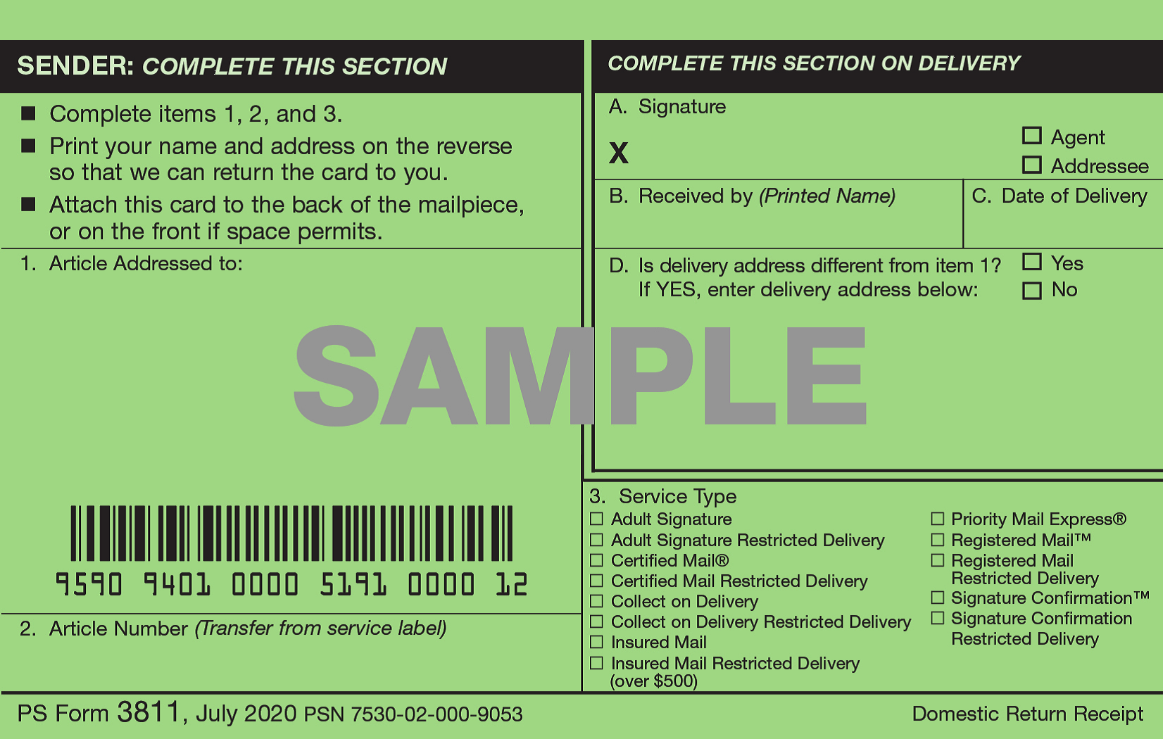
- Once they sign for it, the green card (the “return receipt”) with their signature will be mailed back to you. When you receive it, double-check that it was signed for by the other person and not someone else.
- Attach the green card to the Proof of Service form. The person who mailed the paperwork needs to fill out the Proof of Service form all the way until the signature line. They then need to sign in front of a notary and file the Proof of Service form with the Circuit Court Clerk’s office.
- Service by certified mail can be cheaper than hiring a process server, but it can take longer for service to be completed (anywhere from a few days to a few weeks).

FIRST CLASS MAIL (double check the chart above to ensure this is an allowable method of service)
- Mail paperwork to Respondent using first class mail, ensuring that there is enough postage.
- The person who mailed the paperwork then needs to fill out the Proof of Service form all the way until the signature line. They then need to sign in front of a notary and file the Proof of Service form with the Circuit Court Clerk’s office.

IF YOU’VE TRIED TO SERVE THE OTHER PARTY BUT HAVE BEEN UNSUCCESSFUL, you can ask the court for a different way to serve by filing a Motion for Alternate Service, where you will explain the ways you have attempted service and see whether the court will grant you permission to give the other party notice a different way. This paperwork is available from the PPO Office and the Circuit Court Clerk’s Office.

